**Admin/Adviser Side**

1. Tasks Page

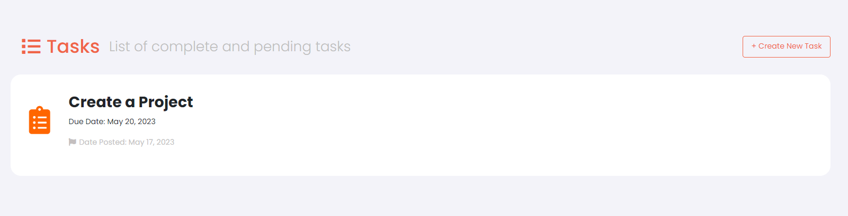

Gumagana yung pag create ng task. Ang problema dito, tuwing ioopen yung task, Placeholder palang tong lahat.

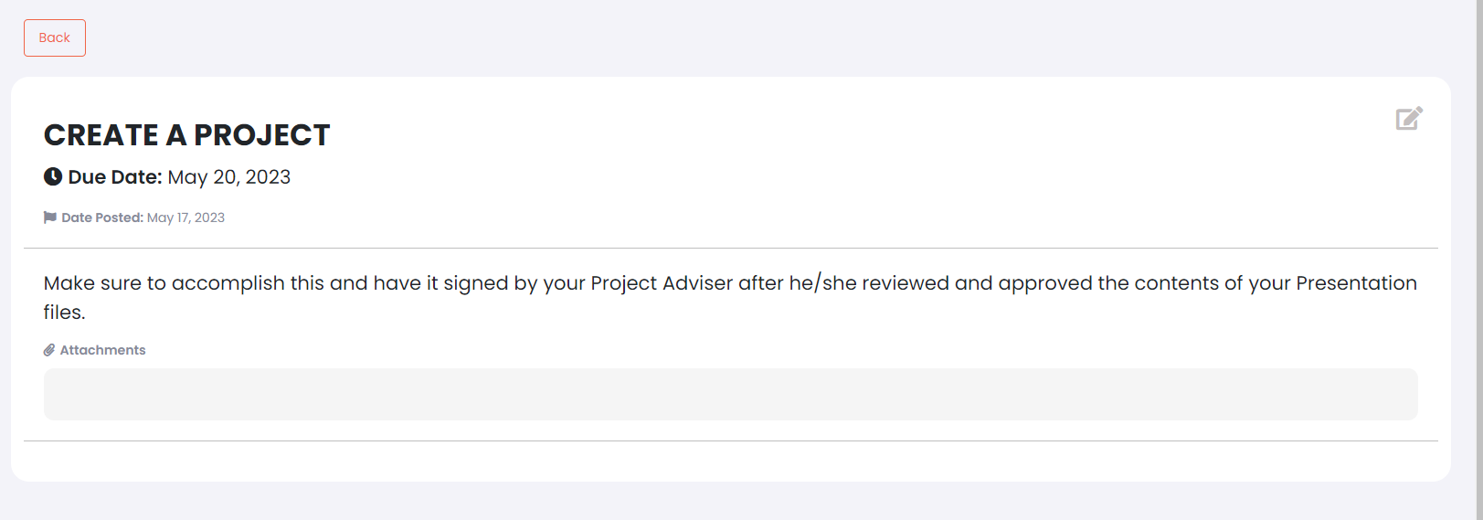

Basically, Need maiconnect yung data sa pag create ng page sa pagview ng page.



Next, Hindi pa usable yung edit button since walang route for it. See pic below.

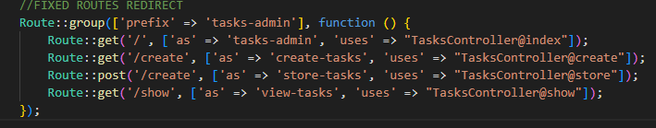

**Student Side**

1. Task View Page

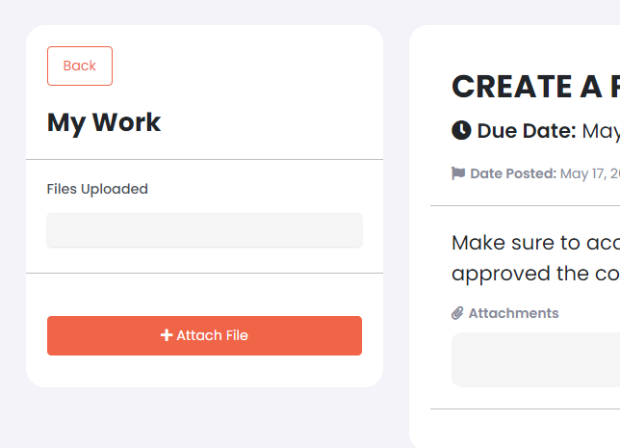

May button for Attach File, it’s clickable, but not working.

I want to be able to attach file and submit it.

1. Advisers Page

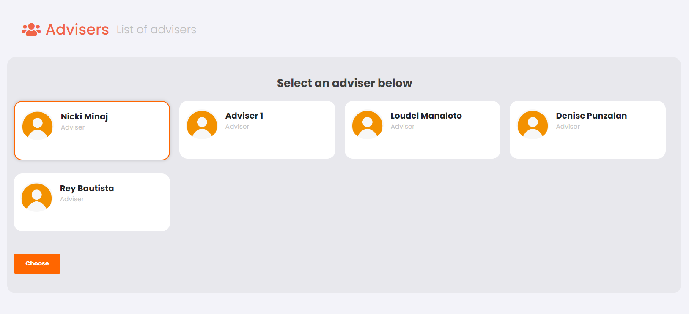

I can select an Adviser and may button for Choose, it’s clickable, but again its not working. After choosing an Adviser, Dapat mag nonotif siya dito sa **Adviser Side.** The Adviser can either Accept or dismiss.

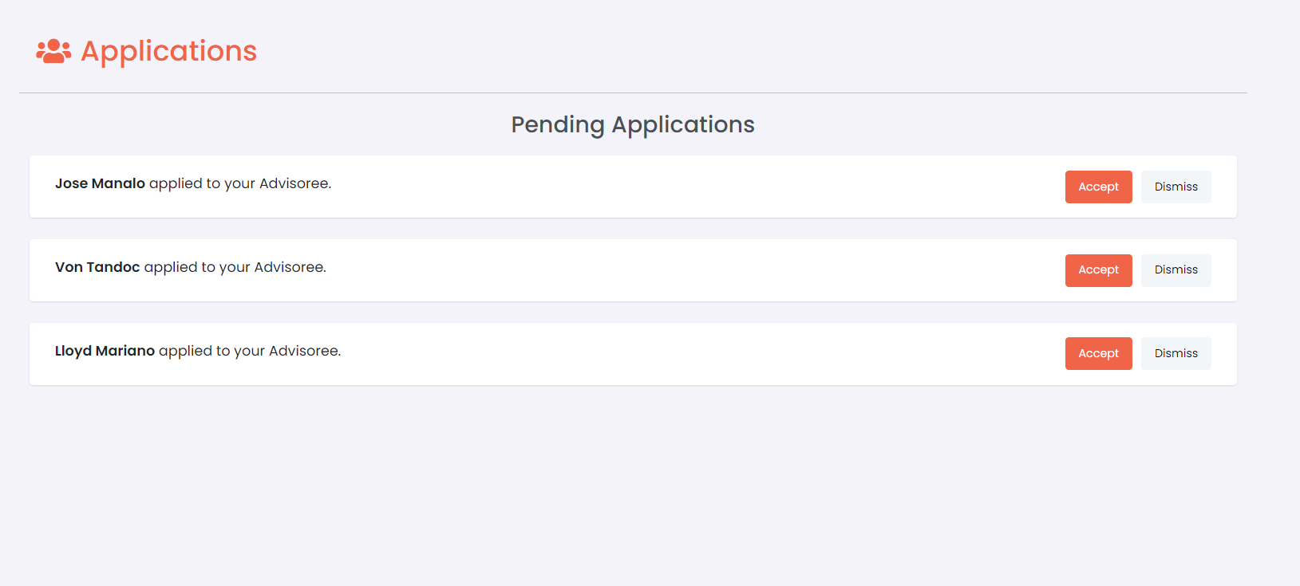

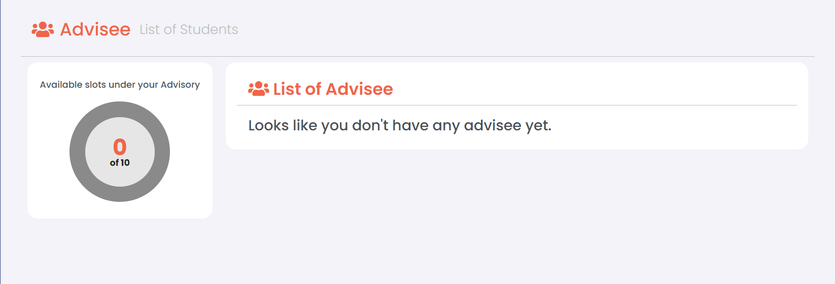

After maaccept si student, mapupunta na siya dito sa list of Advisee. So from the image above, magiging ganito na siya sa baba. Sa graph makacount niya yung student na nasa **List of Advisee** and dapat magchechange din yung progress sa circle graph. (Di ko alam bakit di nagana circle graph ko HAHAHA)

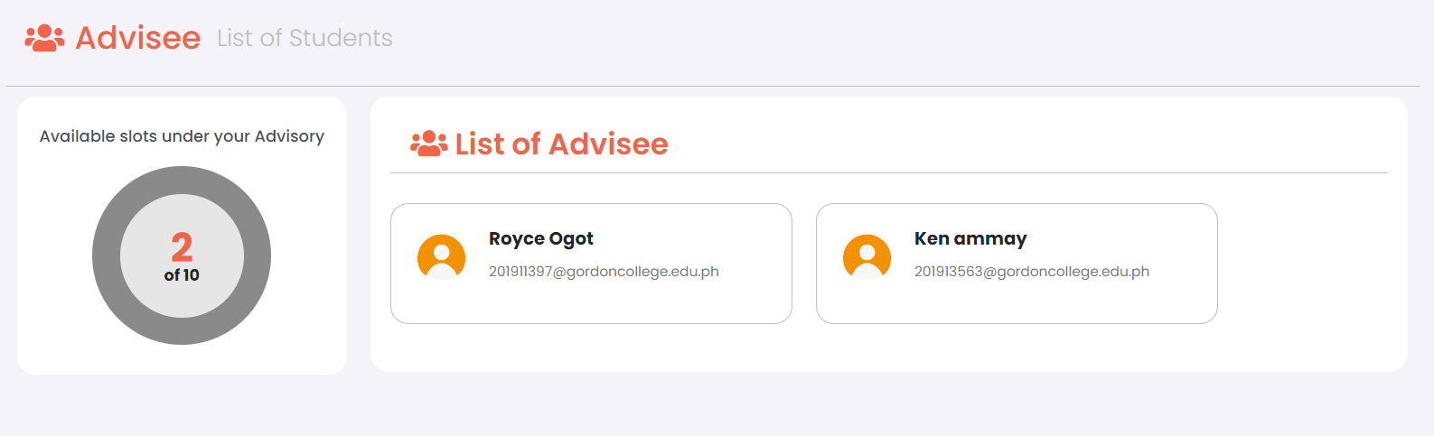

Ito yung **Task Page** for Adviser Side. Pepwede siya mag create ng Task as well, but may limitation yun. Which is yung task na ibibigay niya, yung advisees niya lang dapat ang makakatanggap nun.

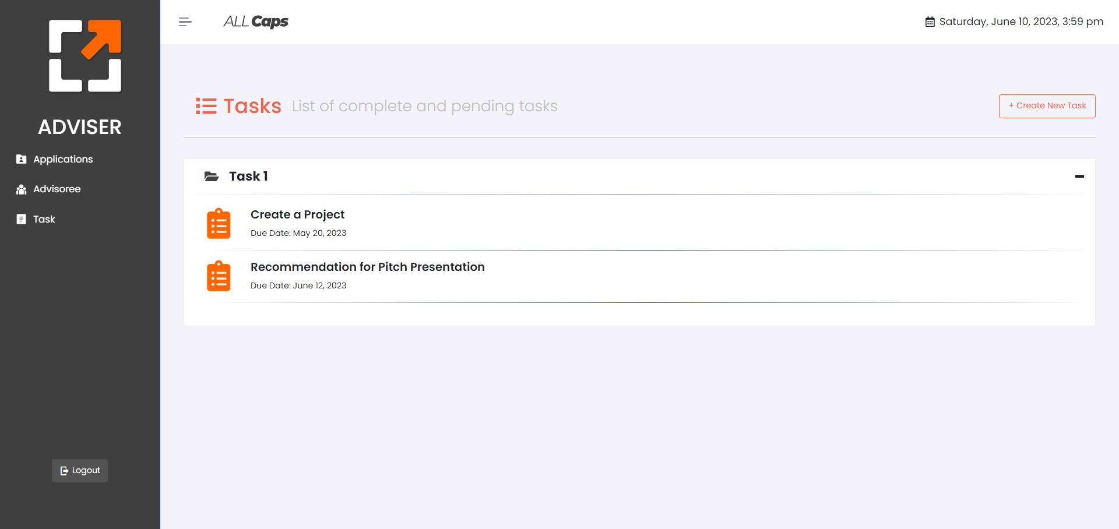

**Admin Side**

1. Tasks Page

This is what the current Tasks Page looks like, binago ko yung UI as per suggestion of Sir Loudel.

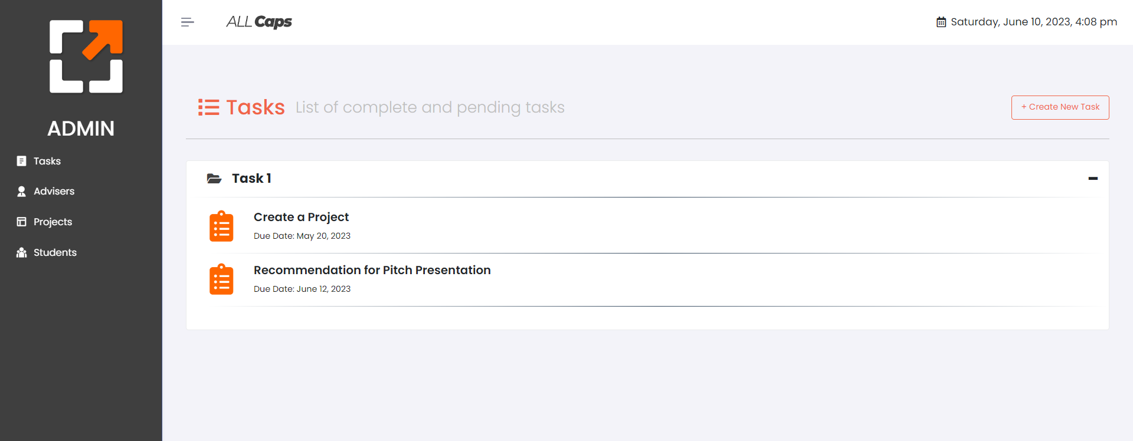

Ito yung sinuggest ni sir na **per Task** meron siyang **Sub-Tasks**. For example, First Task is Pitch Presentation, sa sub-tasks niya andun yung Presentation File, Survey, Lean Canvas etc.

Then Hanggat di nafafinalize yung mga submissions nila sa First Task, Di pa nila maaaccess yung mga tasks na kasunod.

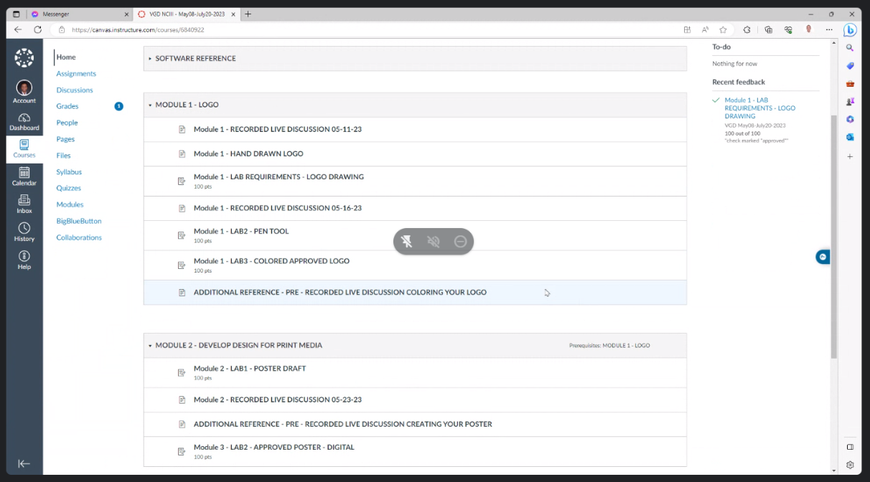

Bali binago ko din dito sa may Create a Task Page, Dinagdagan ko ng another Input. Di ko alam kung ano yung gagawin mong paraan dito but I suggest na User input siya and at the same time magiging drop down din yung choices and madadagdag doon yung nainput na una ni Admin/Adviser. (if that’s possible but you can do your own take din since di ko talaga alam papano to)

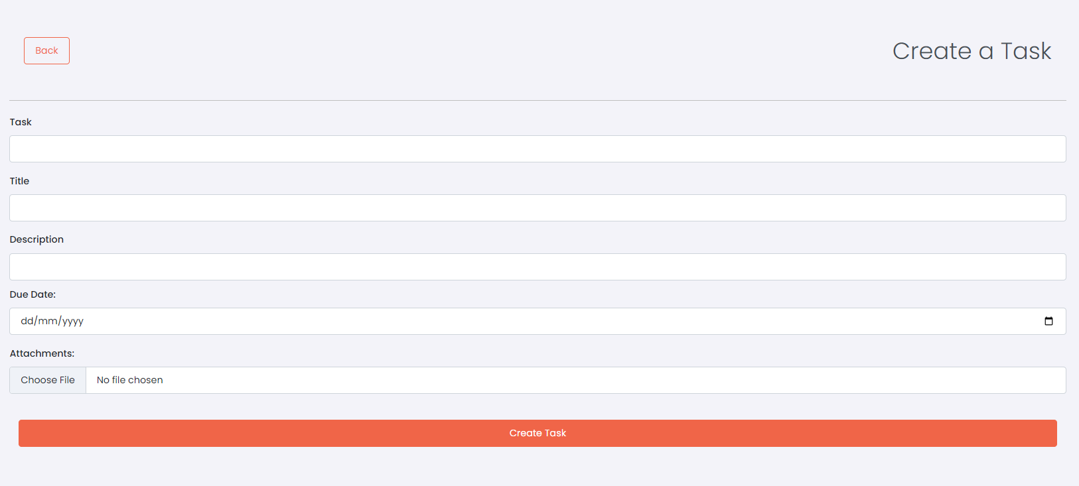

Bali yung input doon sa task sa taas, ayun yung magiging name ng Accordion dito sa baba. Gusto kong maging possible sana na magkaroon ng ibang Task per accordion at the same time, meron silang ibat ibang task sa loob.



1. View Task Page

So, I changed the UI of the View Task page. From this,

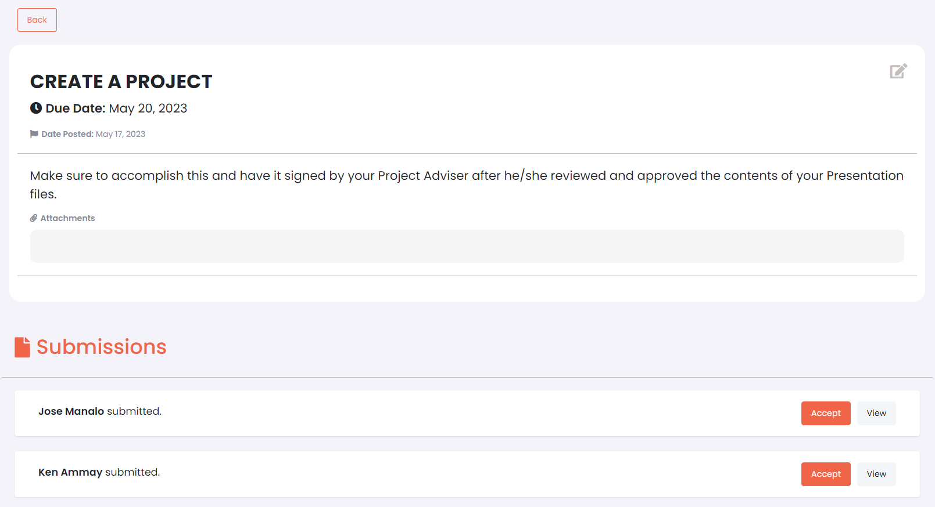

To this. Niremove ko yung Submissions sa baba and nilagay ko sa taas. As per sir Loudel kasi, Maggawa nalang ng designated page for submissions. **Clickable** yung ‘Submissions’ diyan.

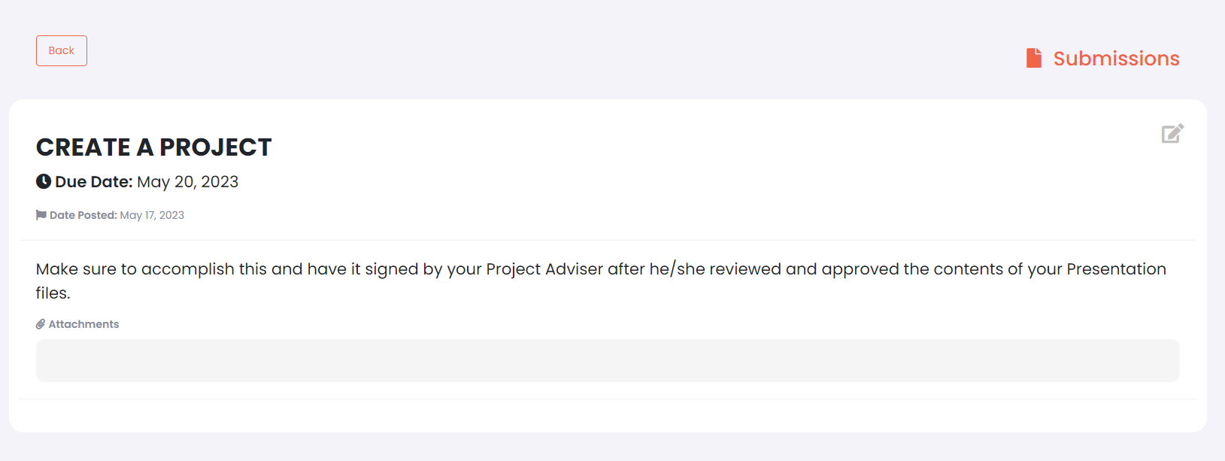

1. Adviser Page

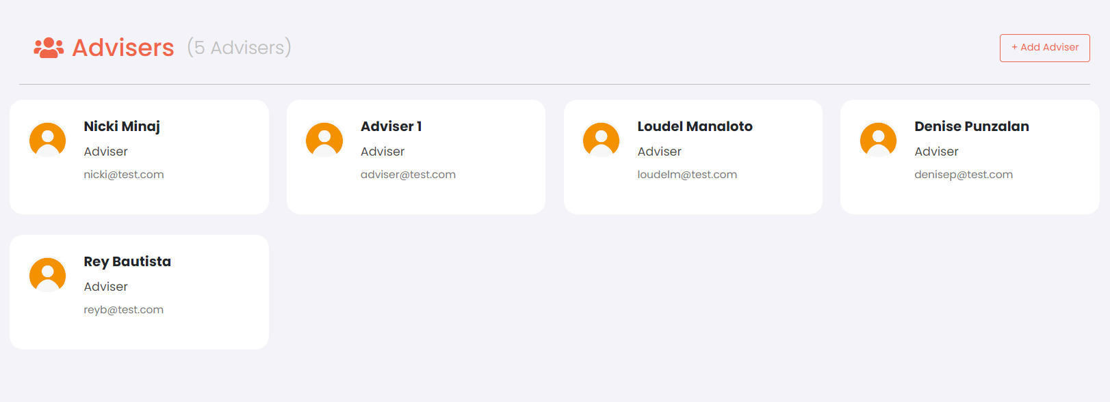

Maging clickable yung every Adviser and makikita dapat sa loob niya yung ganito sa baba.

Here, instead of **Advisee** nakalagay, **“Adviser Profile”** ang ilalagay.



Kagaya sa Profile page ng Student, Magkaron din sana ng ganito sa Adviser Profile Page. Nakalagay siya sa taas ng box ng graph chart.

